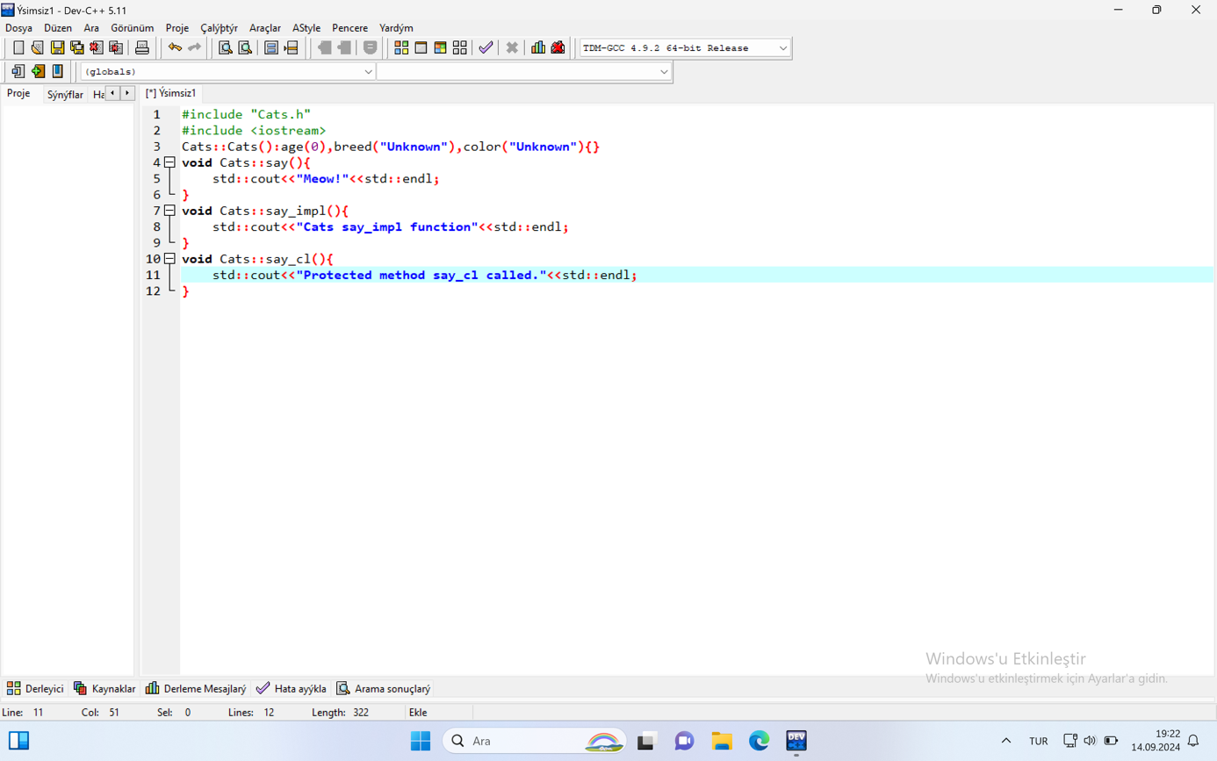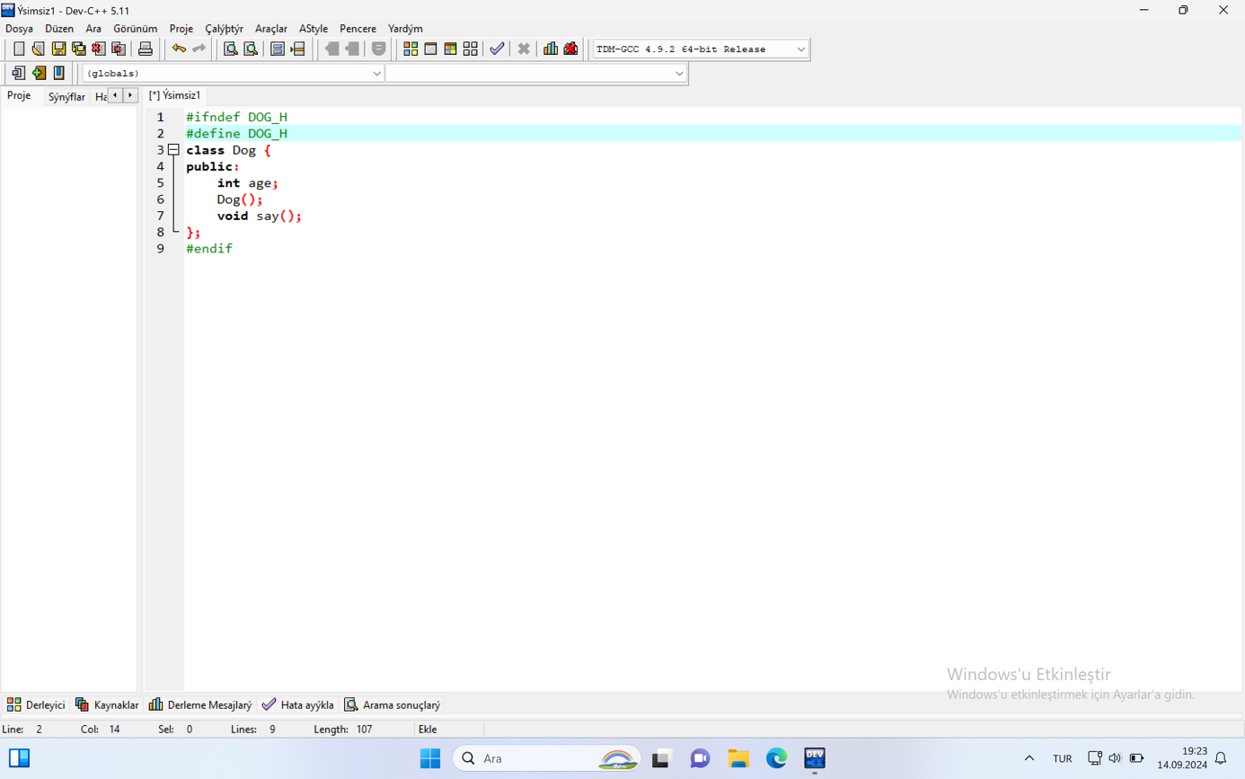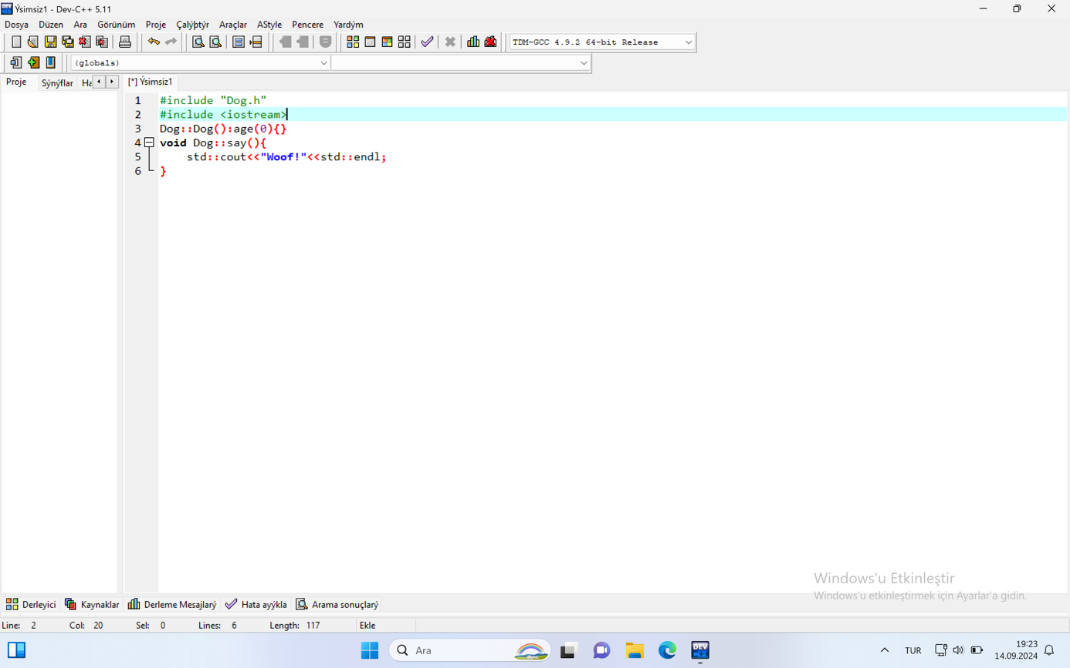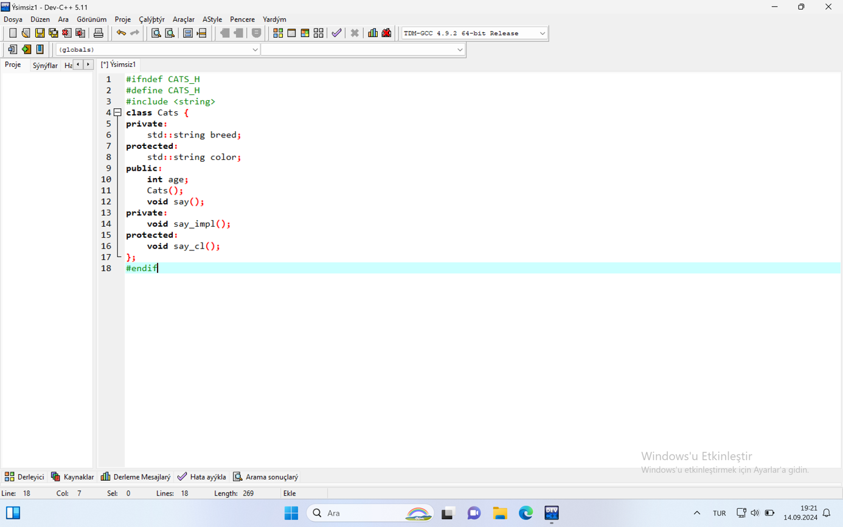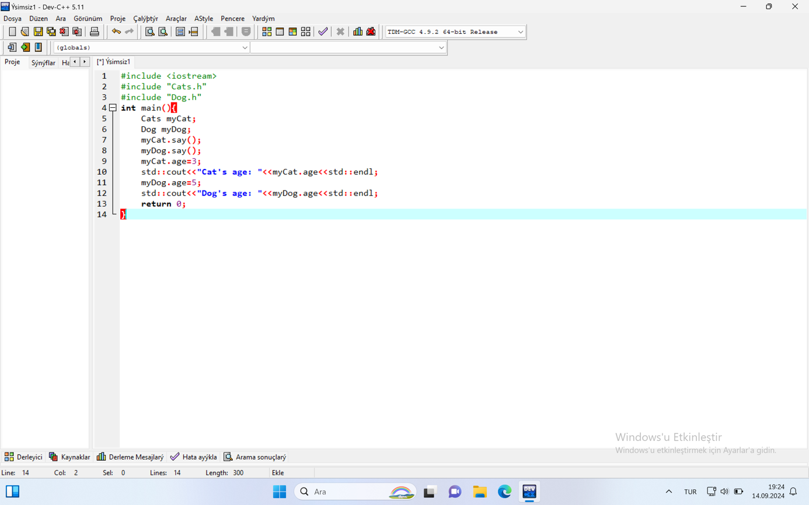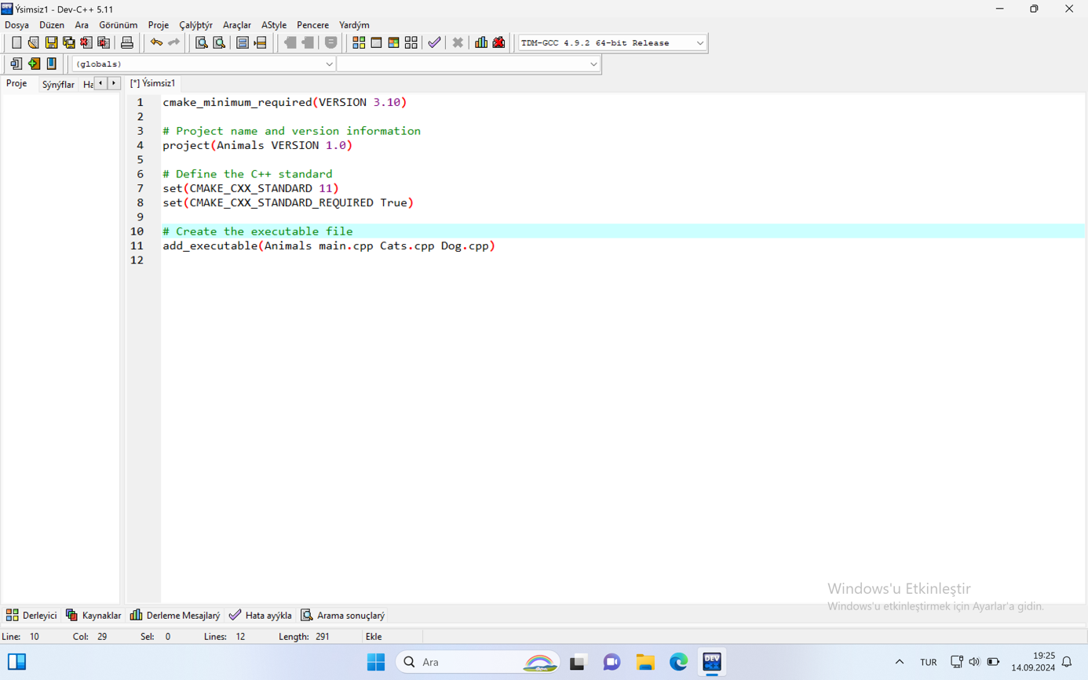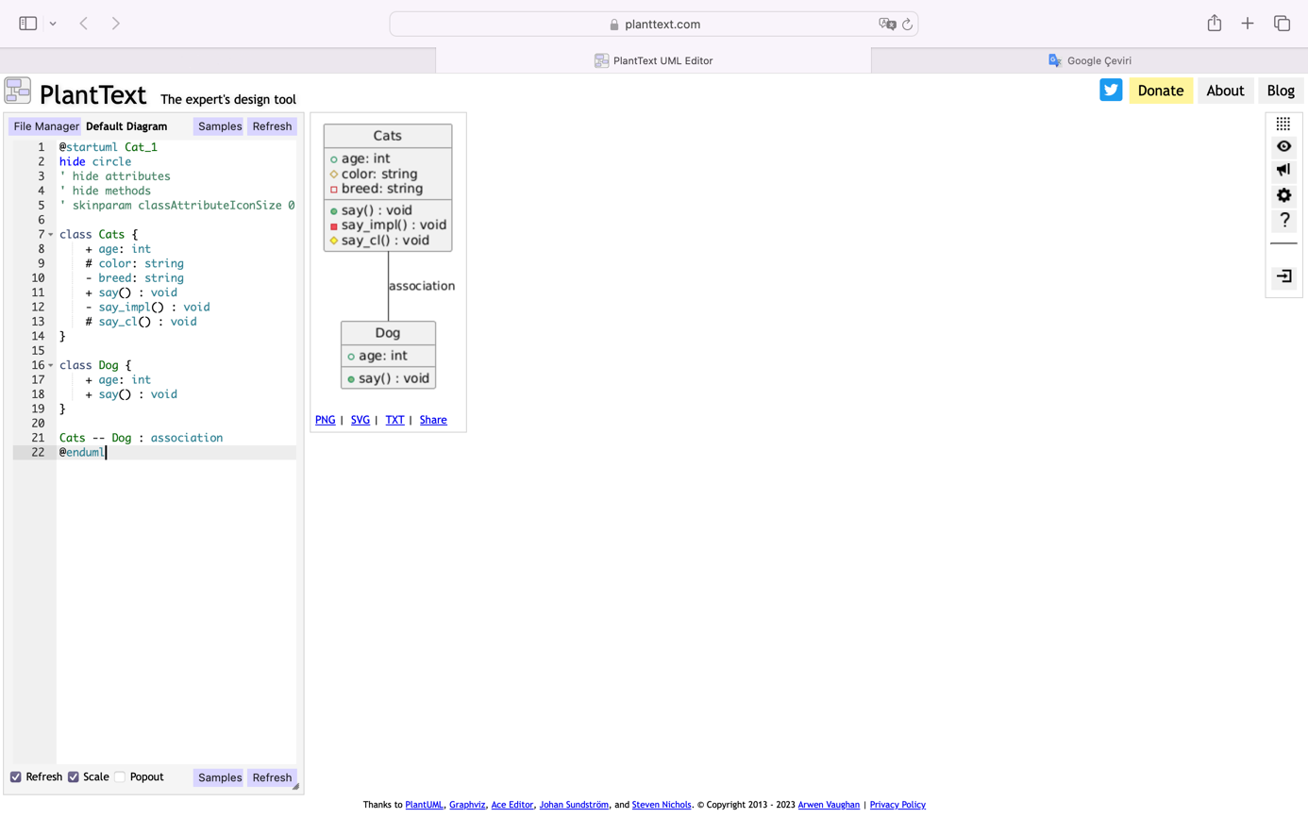

PlantUML Diagram:

Include a screenshot of the screen where you drew the PlantUML diagram.

Project File Structure:

Include a screenshot of the structure of your project folder after creating the C++ files (Cats.h, Cats.cpp, Dog.h, Dog.cpp, main.cpp, CMakeLists.txt).

Compilation and Build:

Include a screenshot of the terminal output after running the CMake and make commands in the terminal.

Program Output:

Include a screenshot of the terminal showing the output you get when you run the program.

Comments:

Explain briefly what each step does and how it works.

Mention any problems you encountered or learned during the build.